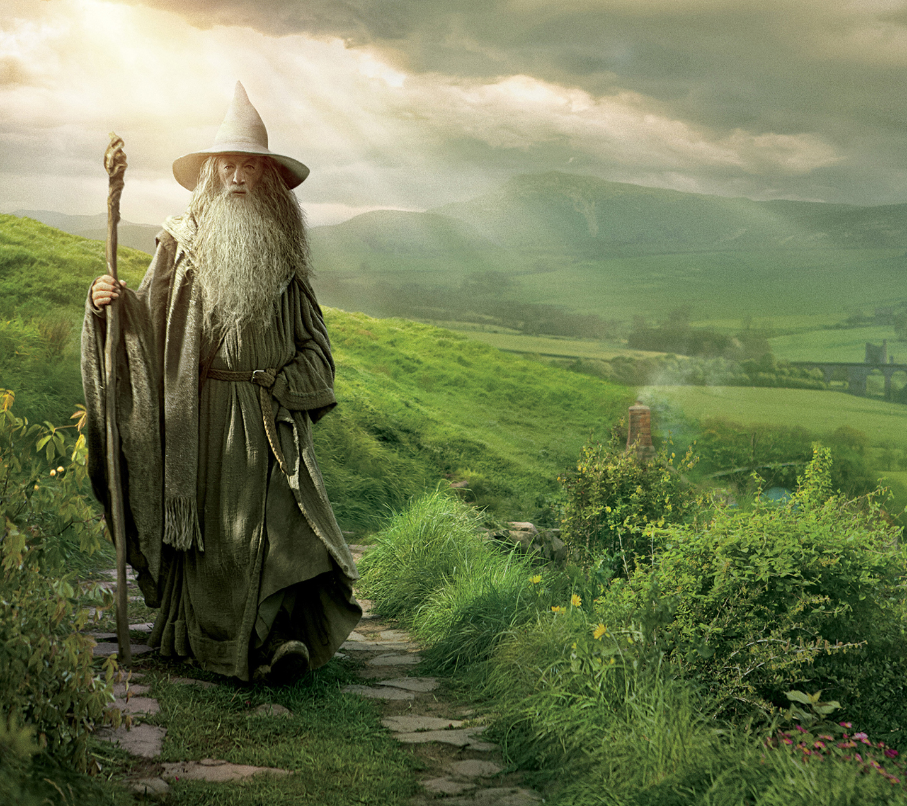
Lyrics
Far over the Misty Mountains cold,
To dungeons 1 and caverns 2,
We must away, ere break of day,
To seek our long forgotten 3.
The pines were roaring on the height.
The winds were moaning in the night.
The 4 was red, it flaming spread.
The 5 like torches blazed with light.

1. Fill in the missing parts of the lyrics.

1
2
3
4
5

2. What do they mean with the last four sentences in the second paragraph? What does this refer to?

